 **EAST WEST UNIVERSITY**

**Department Of CSE**

**CSE302: Database Systems (Sec-6)**

**Summer 2025**

**Project Report**

**ON**

**Food Delivery Management System**

***https://apex.oracle.com/pls/apex/r/malaha_apex/food-delivery-management-system/users-details?session=15014967187088***

**Submitted By:**

|  |  |
| --- | --- |
| **Student ID** | **Student Name** |
| **Samiha Akhter** | **2023-1-60-090** |
| **Dina Mandol** | **2023-1-60-153** |
| **Malaha Oahid Prottasha** | **2023-1-60-203** |

**Submitted To:**

**Mahmuda Rawnak Jahan**

**Lecture, Department of Computer Science and Engineering**

**EAST WEST UNIVERSITY**

**ER Diagram for this Project:**

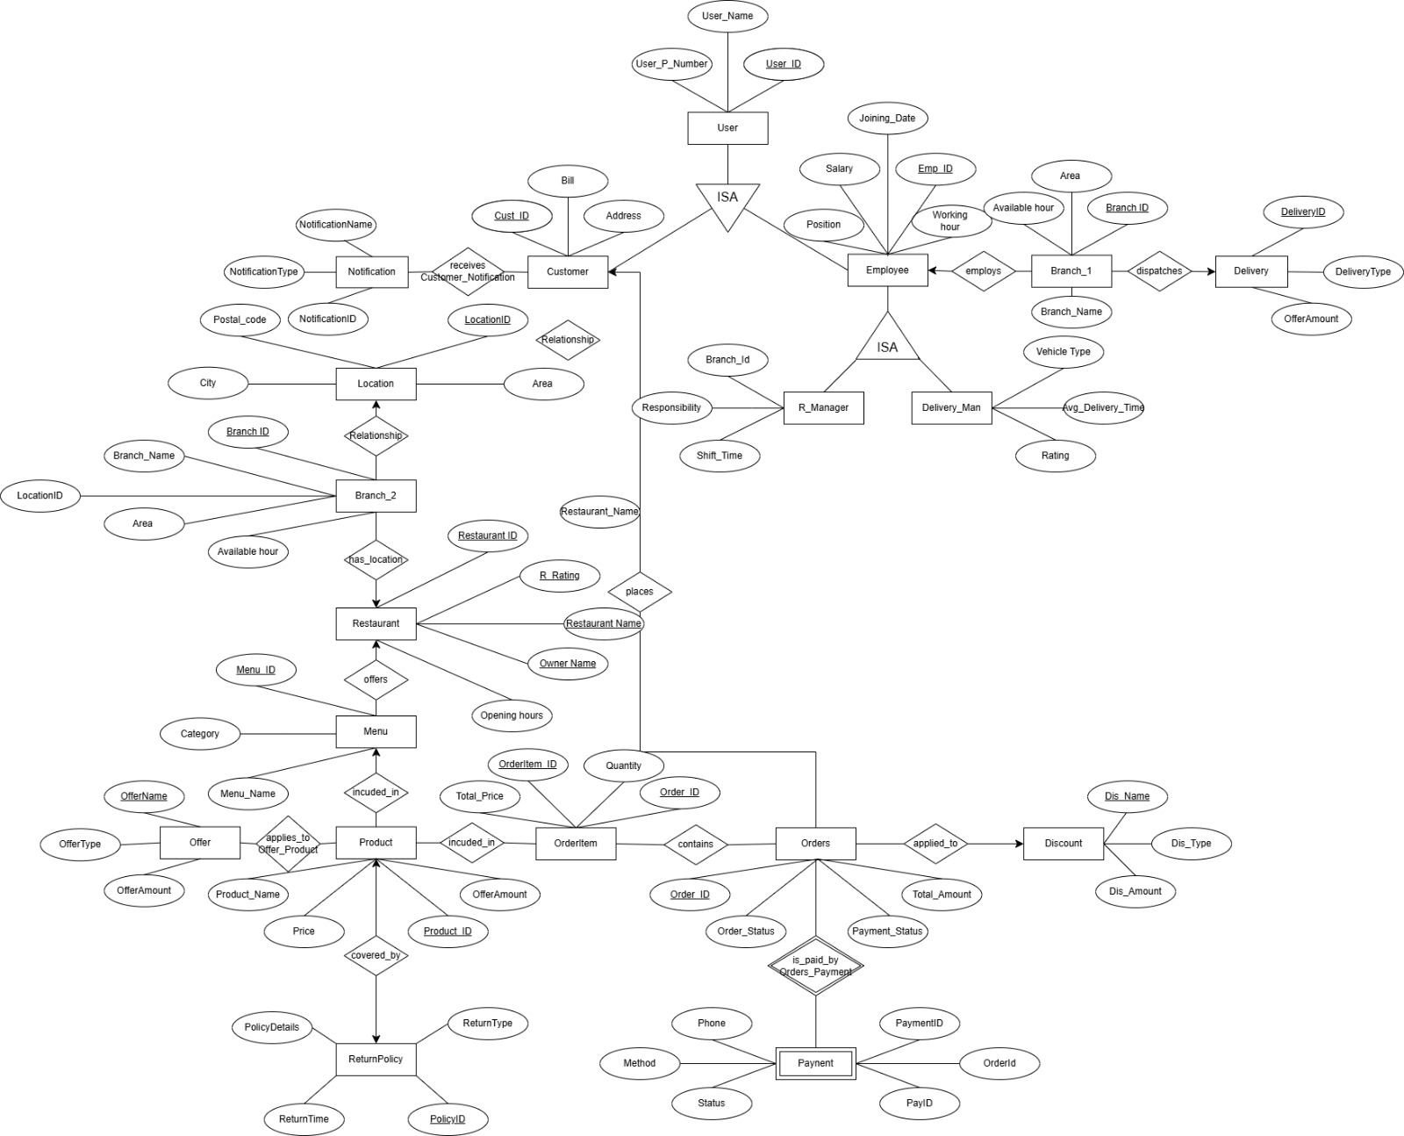

**Schema Diagram:(Logical):**

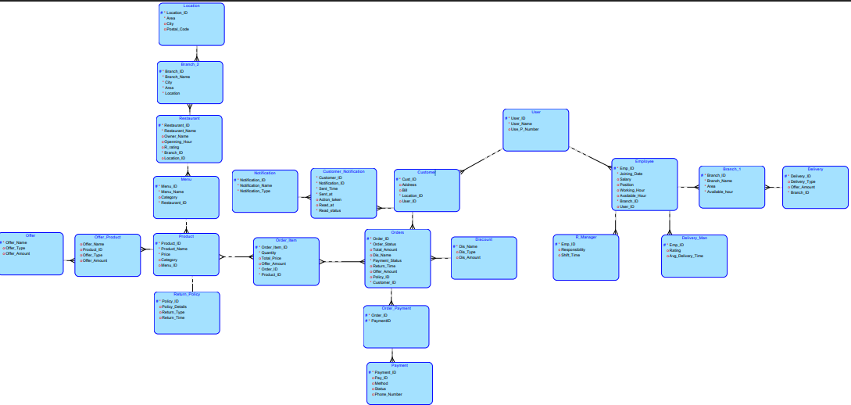

**Schema Diagram:(Relational):**

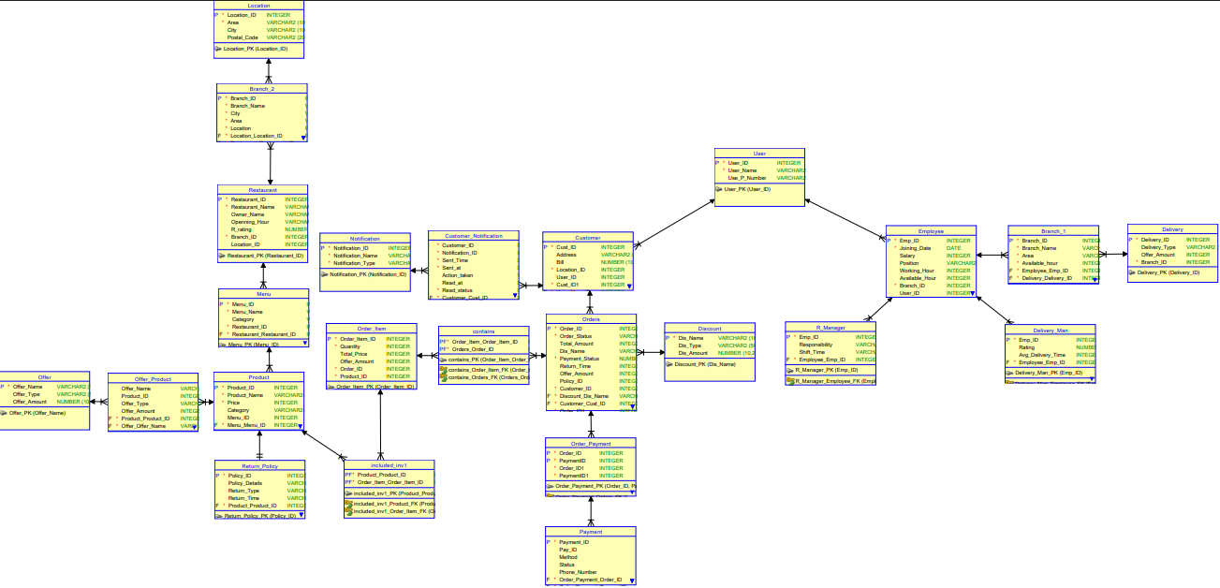

**Table:**

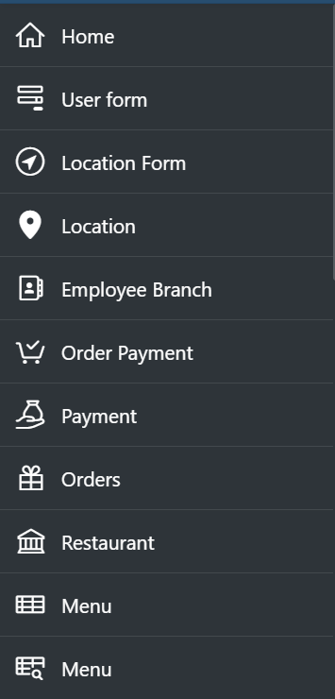

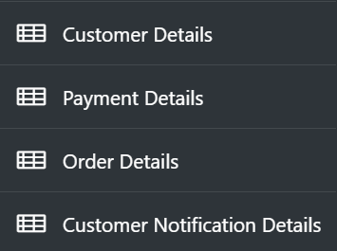

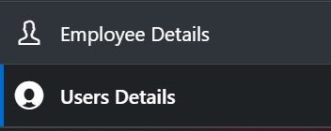

**VIEW:**

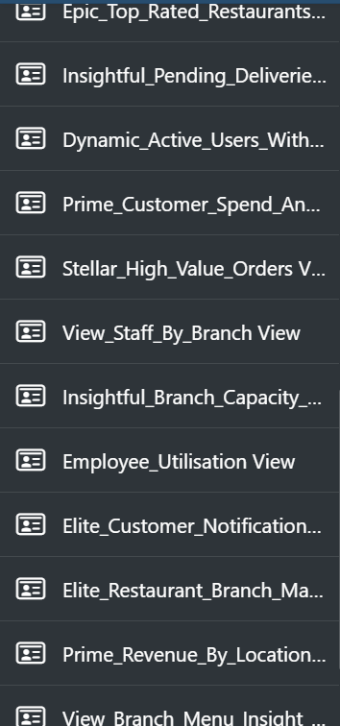

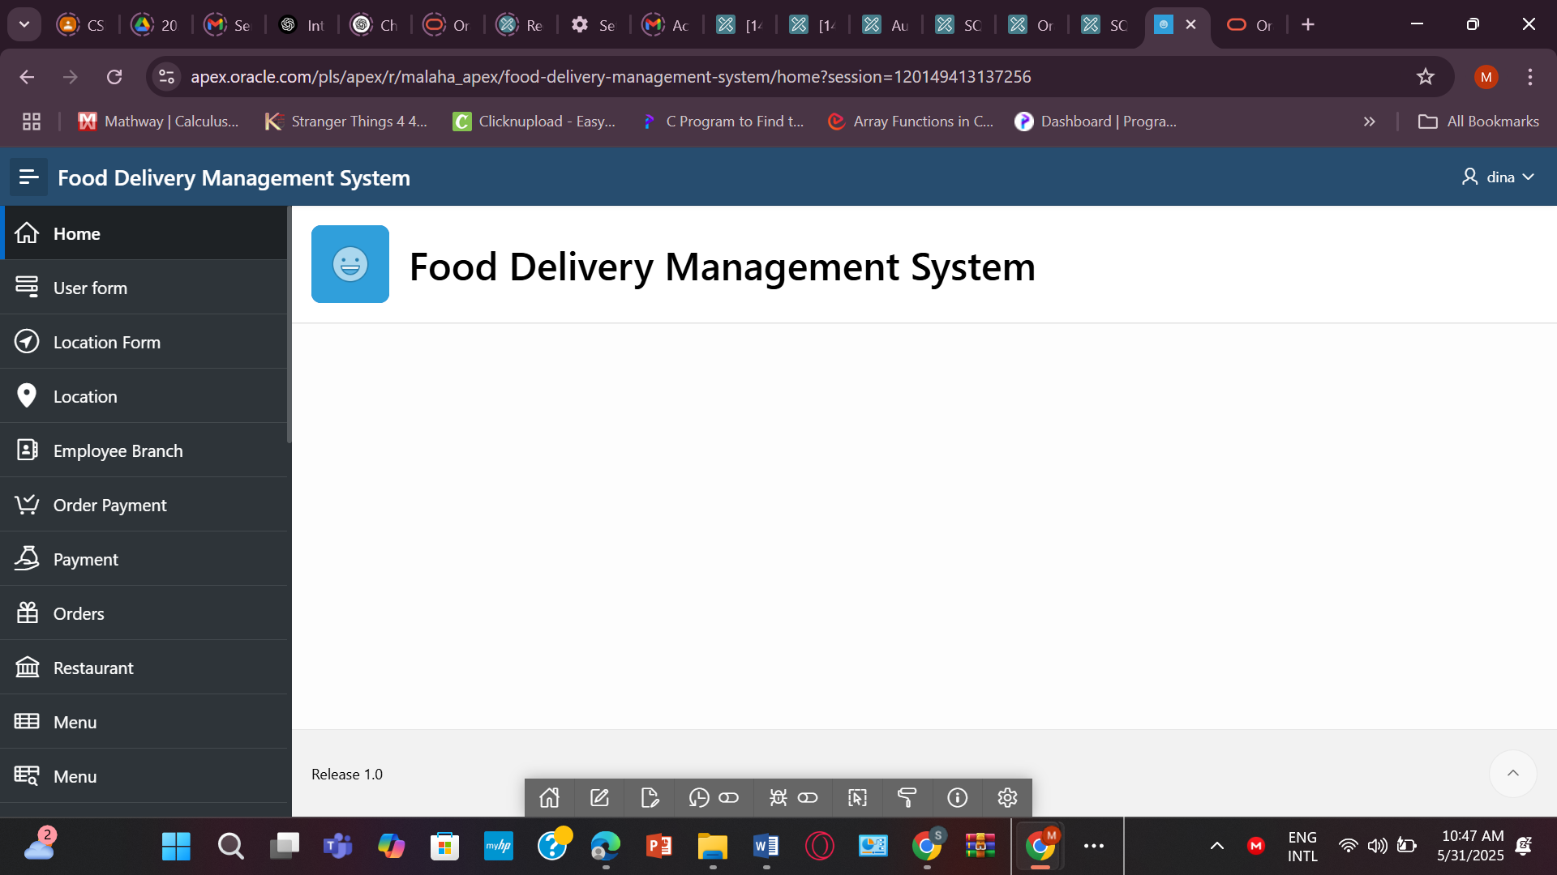

**Tables :**

* **USER_**

**CREATE TABLE USER_ (**

**User_ID NUMBER PRIMARY KEY,**

**User_Name VARCHAR2(100) NOT NULL,**

**User_P_Number VARCHAR2(20)**

**);**

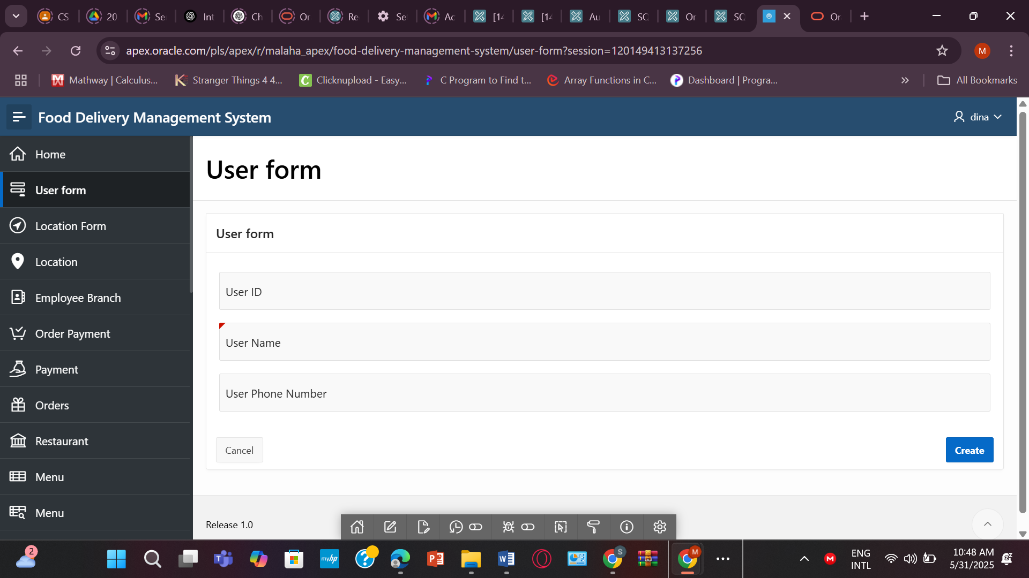

* **LOCATION**

**CREATE TABLE LOCATION (**

**Location_ID NUMBER PRIMARY KEY,**

**Area VARCHAR2(100) NOT NULL,**

**City VARCHAR2(100),**

**Postal_Code VARCHAR2(20));**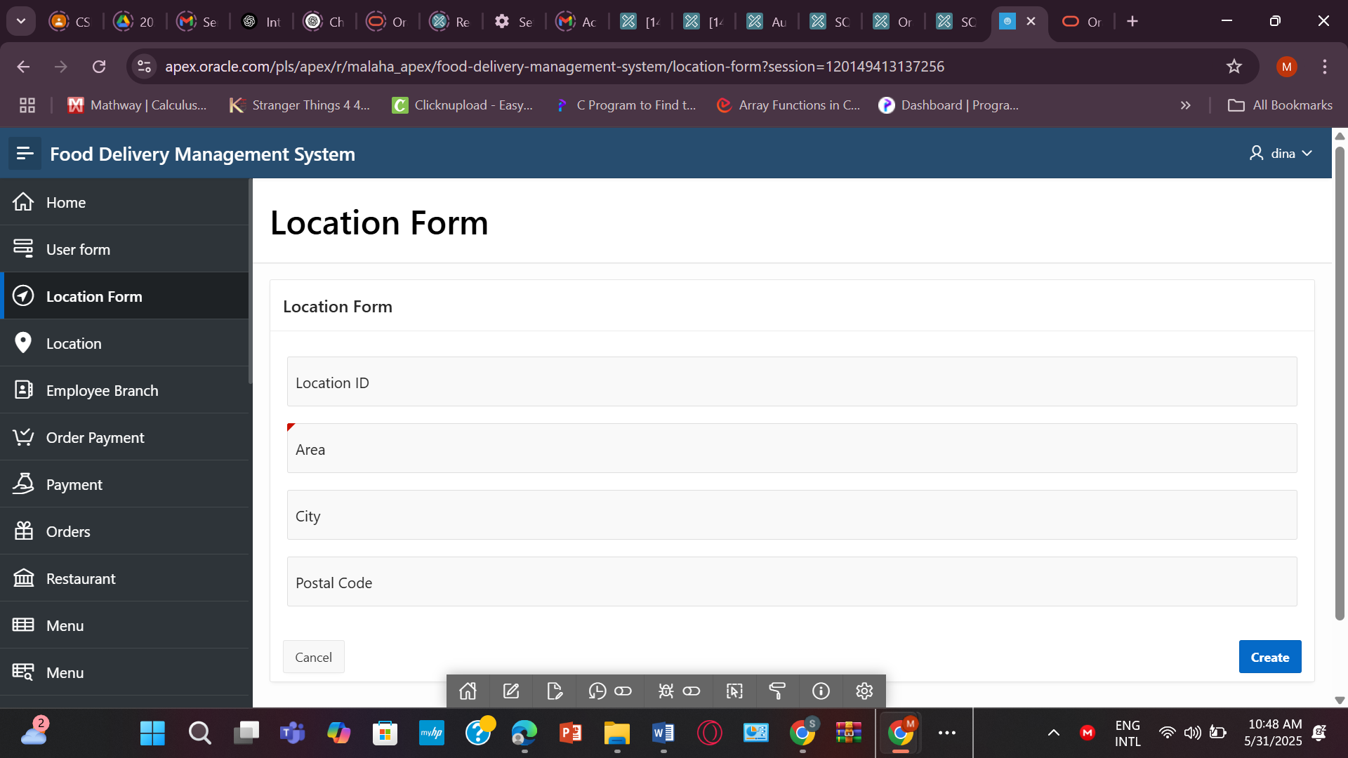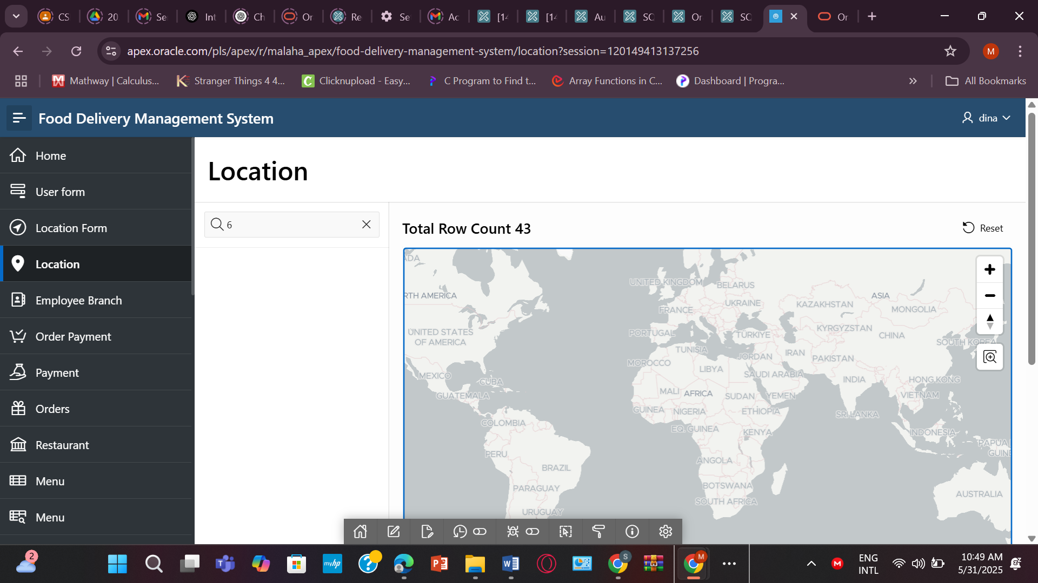

* **EMPLOYEE**

**CREATE TABLE EMPLOYEE (**

**Emp_ID NUMBER PRIMARY KEY,**

**Joining_Date DATE NOT NULL,**

**Salary NUMBER(10,2),**

**Position VARCHAR2(50),**

**Working_hour NUMBER,**

**Available_hour NUMBER,**

**Branch_ID NUMBER NOT NULL,**

**User_ID NUMBER,**

**CONSTRAINT fk_emp_user FOREIGN KEY (User_ID) REFERENCES USER_(User_ID),**

**CONSTRAINT fk_emp_branch FOREIGN KEY (Branch_ID) REFERENCES BRANCH_1(Branch_ID)**

**);**

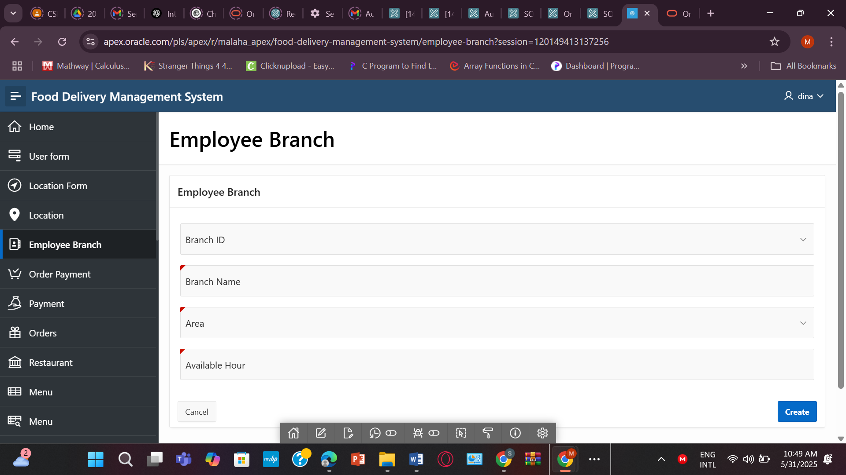

* **ORDER_PAYMENT**

**CREATE TABLE ORDER_PAYMENT (**

**Order_ID NUMBER,**

**PaymentID NUMBER,**

**CONSTRAINT pk_order_payment PRIMARY KEY (Order_ID, PaymentID),**

**CONSTRAINT fk_order FOREIGN KEY (Order_ID) REFERENCES ORDERS(Order_ID),**

**CONSTRAINT fk_payment FOREIGN KEY (PaymentID) REFERENCES PAYMENT(PaymentID)**

**);**

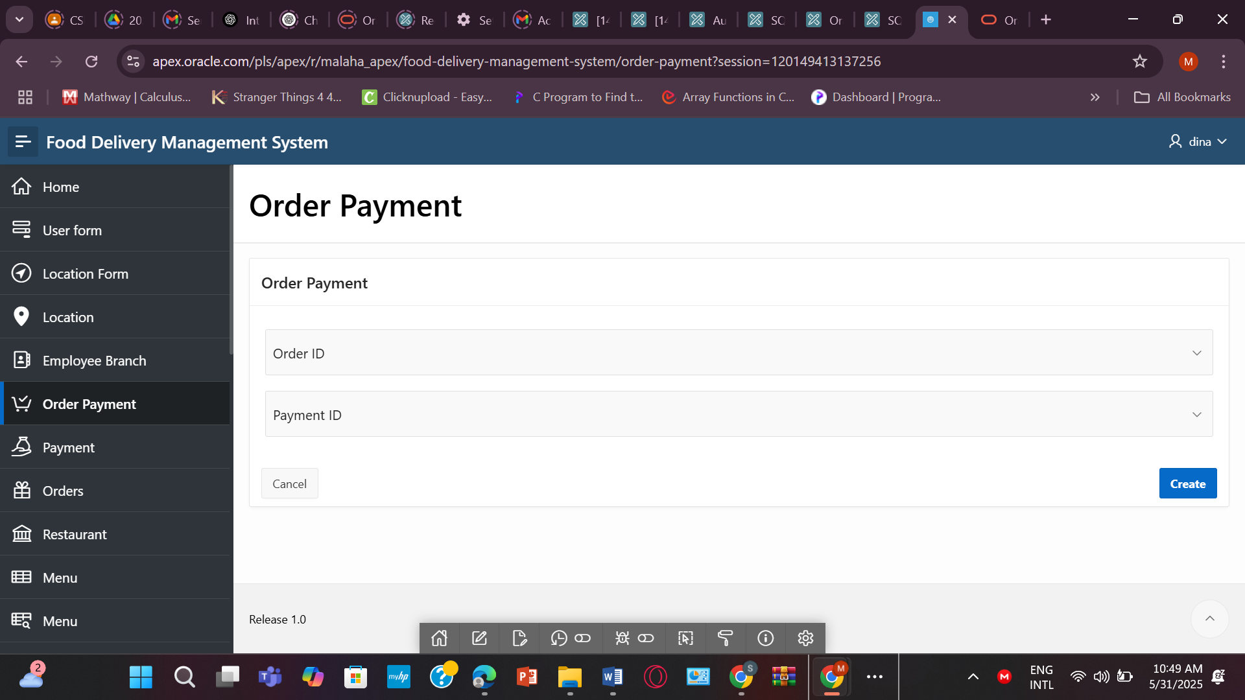

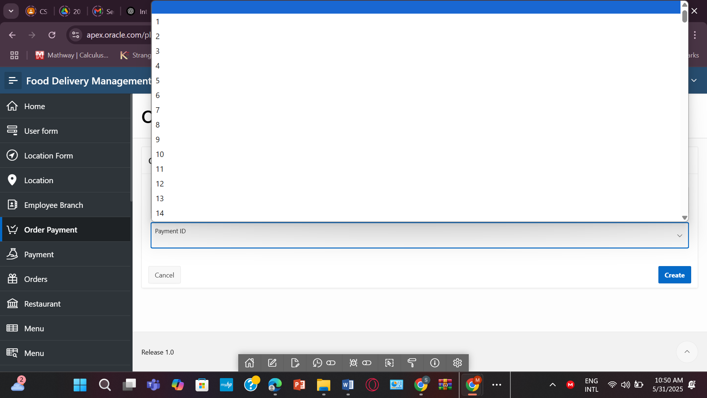

* **PAYMENT**

**CREATE TABLE PAYMENT (**

**PaymentID NUMBER PRIMARY KEY,**

**PayID VARCHAR2(100),**

**Method VARCHAR2(50),**

**Status VARCHAR2(50),**

**Phone VARCHAR2(20)**

**);**

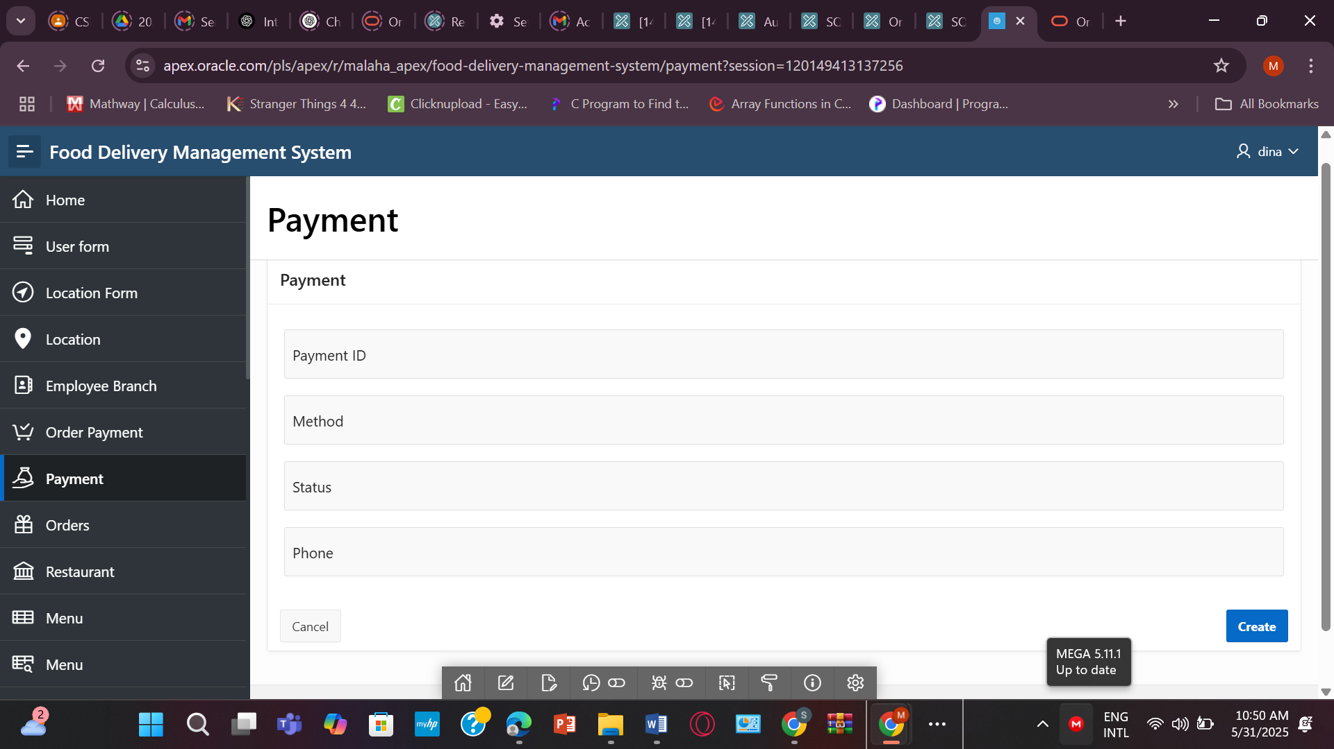

* **ORDERS**

**CREATE TABLE ORDERS (**

**Order_ID NUMBER PRIMARY KEY,**

**Order_Status VARCHAR2(50) NOT NULL,**

**Total_Amount NUMBER(10,2),**

**Dis_Name VARCHAR2(100),**

**Payment_Status VARCHAR2(50) NOT NULL,**

**PolicyID NUMBER,**

**Cust_ID NUMBER NOT NULL,**

**CONSTRAINT fk_order_discount FOREIGN KEY (Dis_Name) REFERENCES DISCOUNT(Dis_Name),**

**CONSTRAINT fk_order_customer FOREIGN KEY (Cust_ID) REFERENCES CUSTOMER(Cust_ID)**

**);  
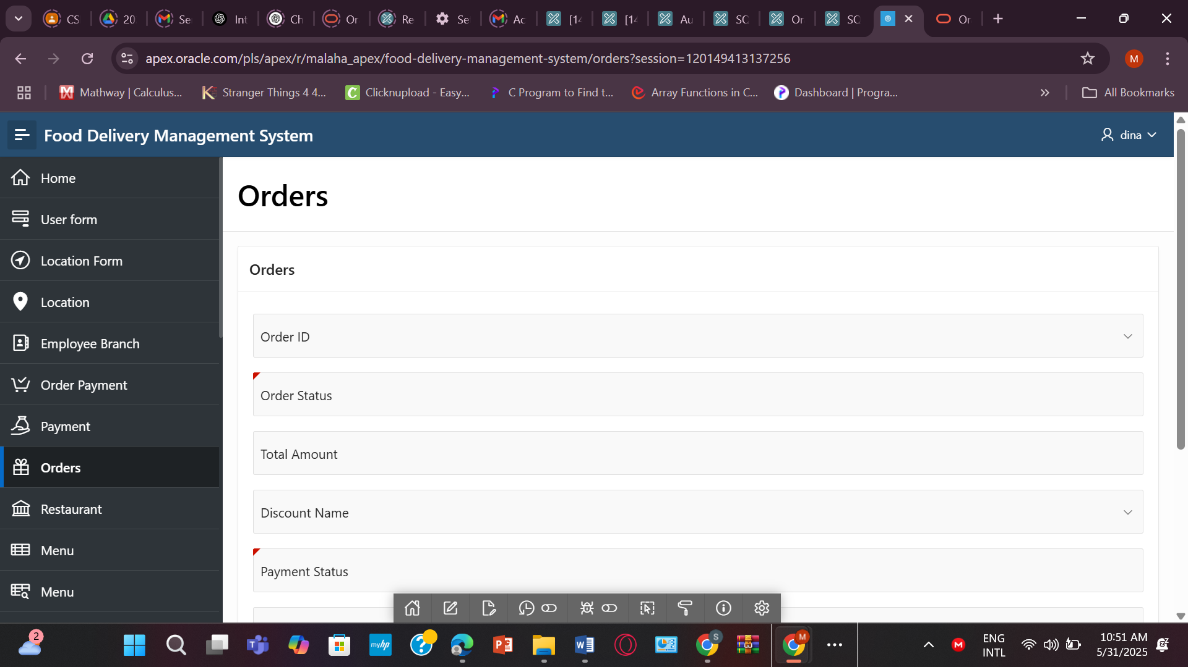**

* **RESTAURANT**

**CREATE TABLE RESTAURANT (**

**Restaurant_ID NUMBER PRIMARY KEY,**

**Restaurant_Name VARCHAR2(100) NOT NULL,**

**Owner_Name VARCHAR2(100),**

**Opening_hours VARCHAR2(50),**

**R_Rating NUMBER(3,2),**

**Branch_ID NUMBER NOT NULL,**

**LocationID NUMBER,**

**CONSTRAINT fk_restaurant_branch2 FOREIGN KEY (Branch_ID) REFERENCES BRANCH_2(Branch_ID),**

**CONSTRAINT fk_restaurant_location FOREIGN KEY (LocationID) REFERENCES LOCATION(Location_ID)**

**);  
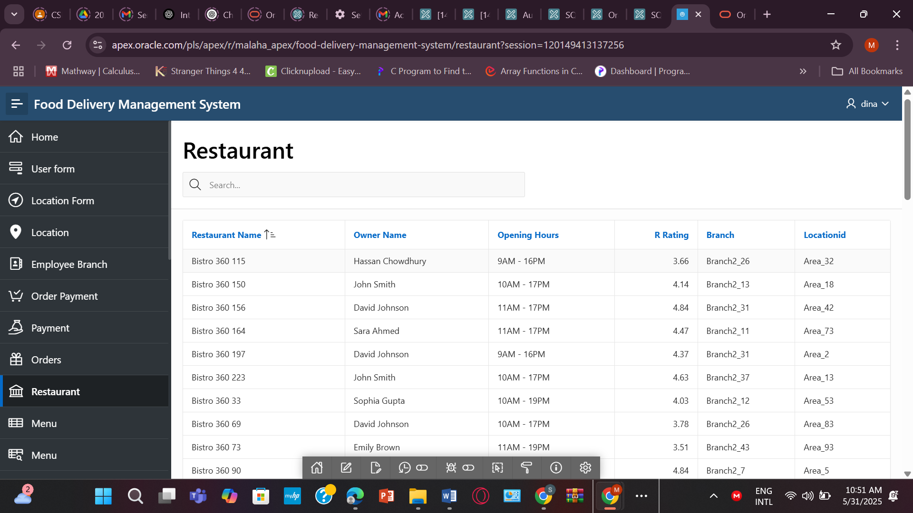**

* **MENU**

**CREATE TABLE MENU (**

**Menu_ID NUMBER PRIMARY KEY,**

**Menu_Name VARCHAR2(100) NOT NULL,**

**Category VARCHAR2(50),**

**Restaurant_ID NUMBER NOT NULL,**

**CONSTRAINT fk_menu_restaurant FOREIGN KEY (Restaurant_ID) REFERENCES RESTAURANT(Restaurant_ID)**

**);**

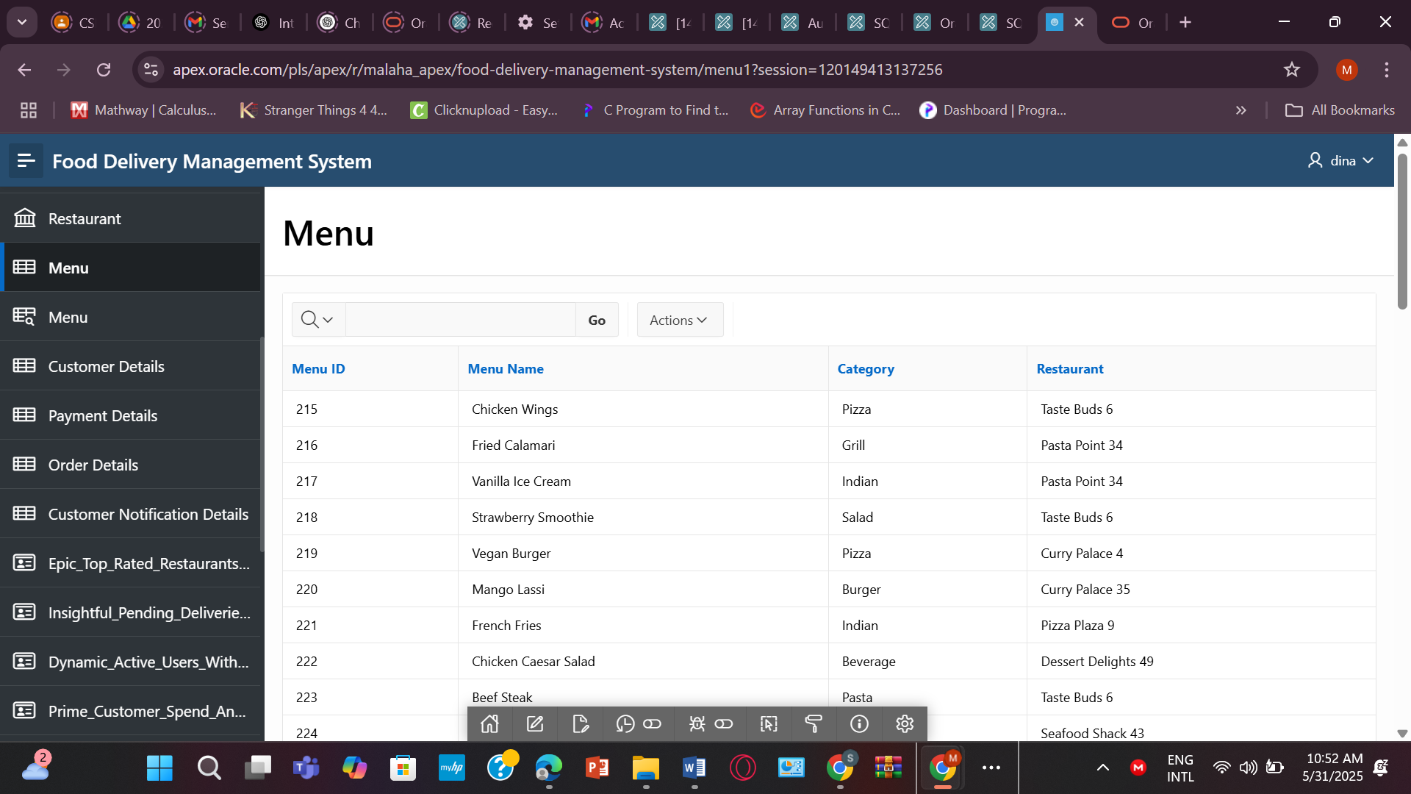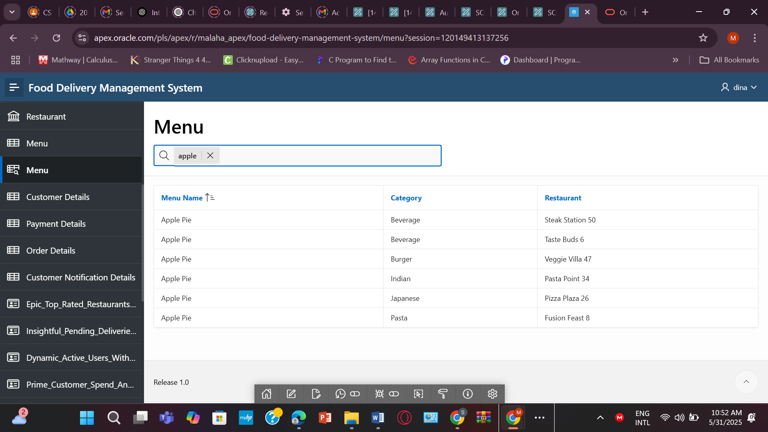

* **CUSTOMER**

**CREATE TABLE CUSTOMER (**

**Cust_ID NUMBER PRIMARY KEY,**

**Address VARCHAR2(200),**

**Bill NUMBER(10,2),**

**NotificationID NUMBER NOT NULL,**

**User_ID NUMBER,**

**CONSTRAINT fk_customer_notification FOREIGN KEY (NotificationID) REFERENCES NOTIFICATION(NotificationID),**

**CONSTRAINT fk_customer_user FOREIGN KEY (User_ID) REFERENCES USER_(User_ID)**

**);  
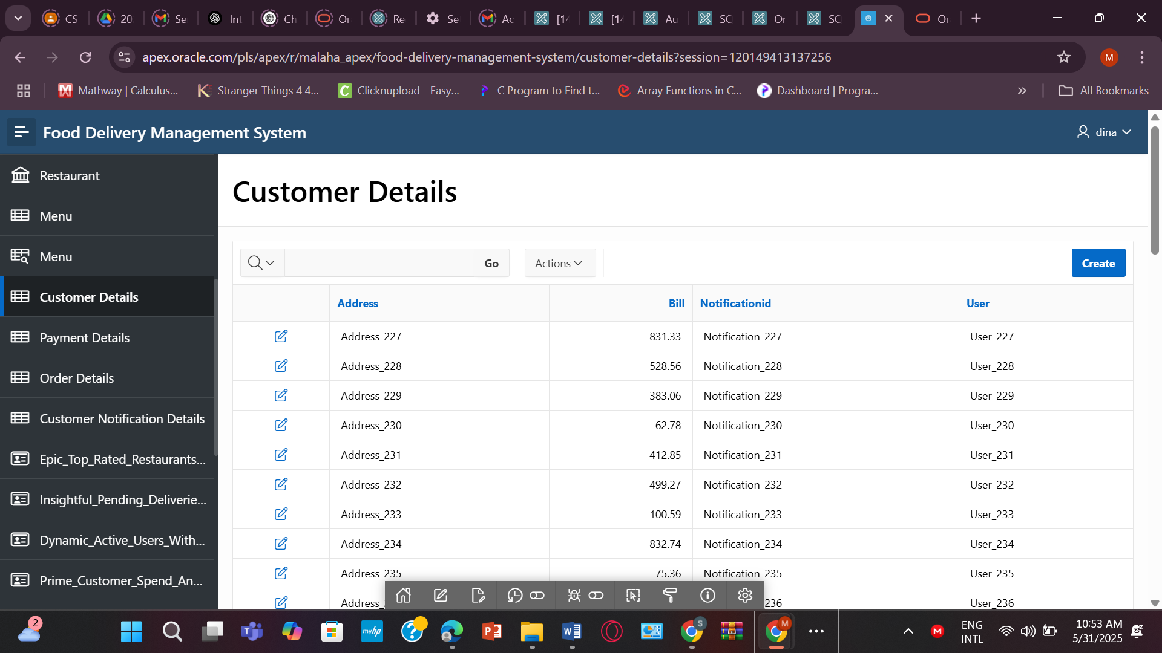**

* **PAYMENT**

**CREATE TABLE PAYMENT (**

**PaymentID NUMBER PRIMARY KEY,**

**PayID VARCHAR2(100),**

**Method VARCHAR2(50),**

**Status VARCHAR2(50),**

**Phone VARCHAR2(20)**

**);  
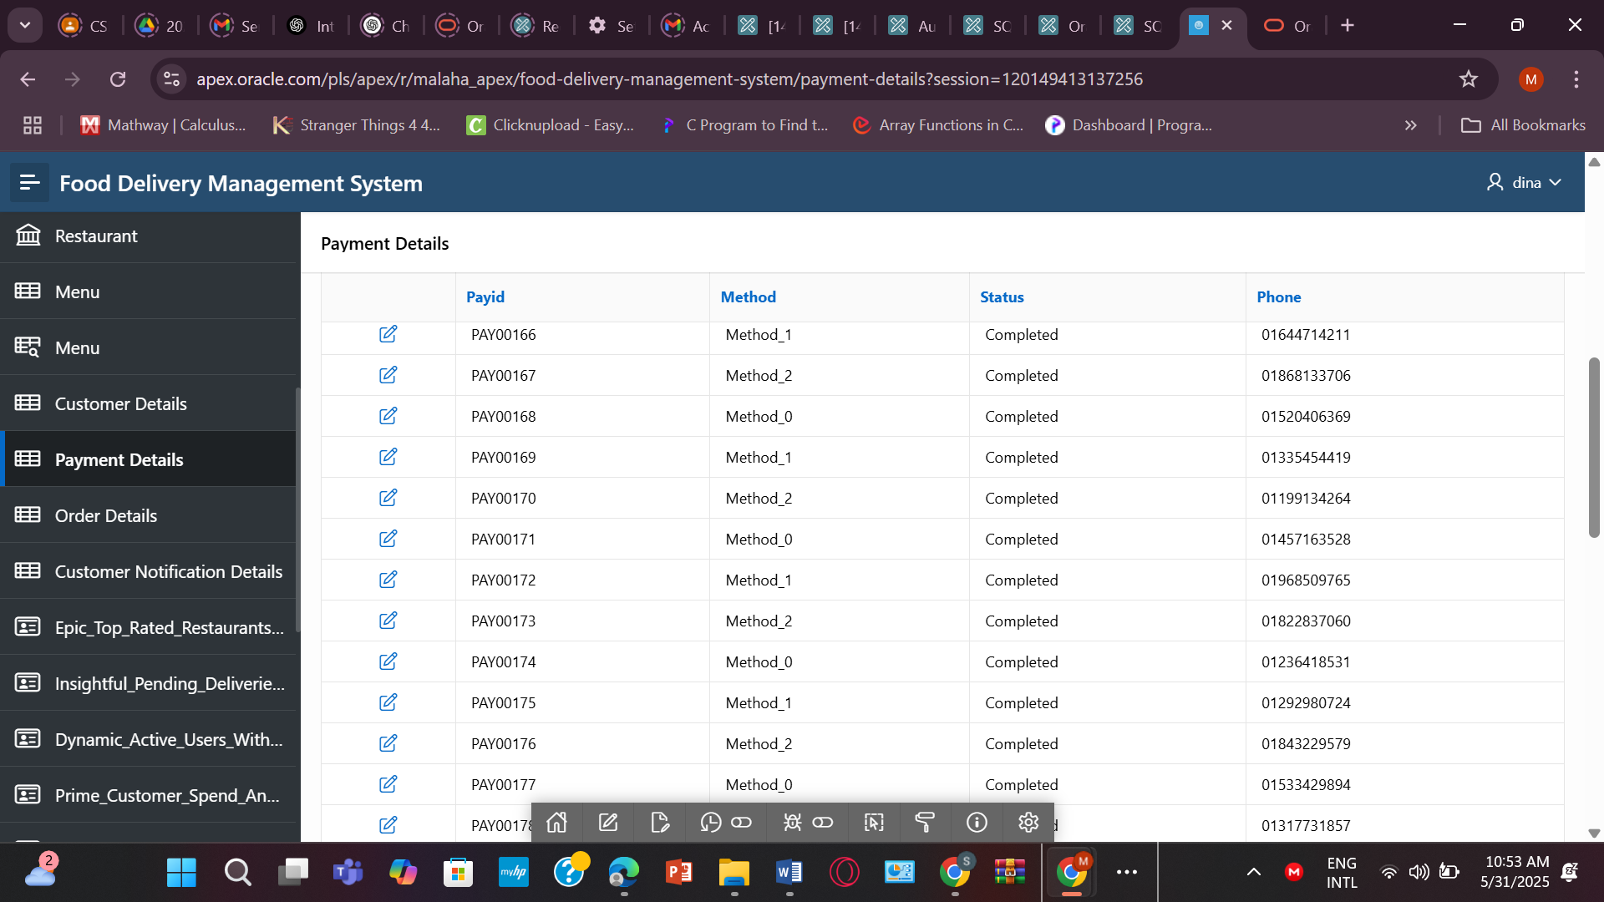**

* **ORDERS**

**CREATE TABLE ORDERS (**

**Order_ID NUMBER PRIMARY KEY,**

**Order_Status VARCHAR2(50) NOT NULL,**

**Total_Amount NUMBER(10,2),**

**Payment_Status VARCHAR2(50) NOT NULL,**

**PolicyID NUMBER,**

**CONSTRAINT fk_order_discount FOREIGN KEY (Dis_Name) REFERENCES DISCOUNT(Dis_Name),**

**CONSTRAINT fk_order_customer FOREIGN KEY (Cust_ID) REFERENCES CUSTOMER(Cust_ID)**

**);  
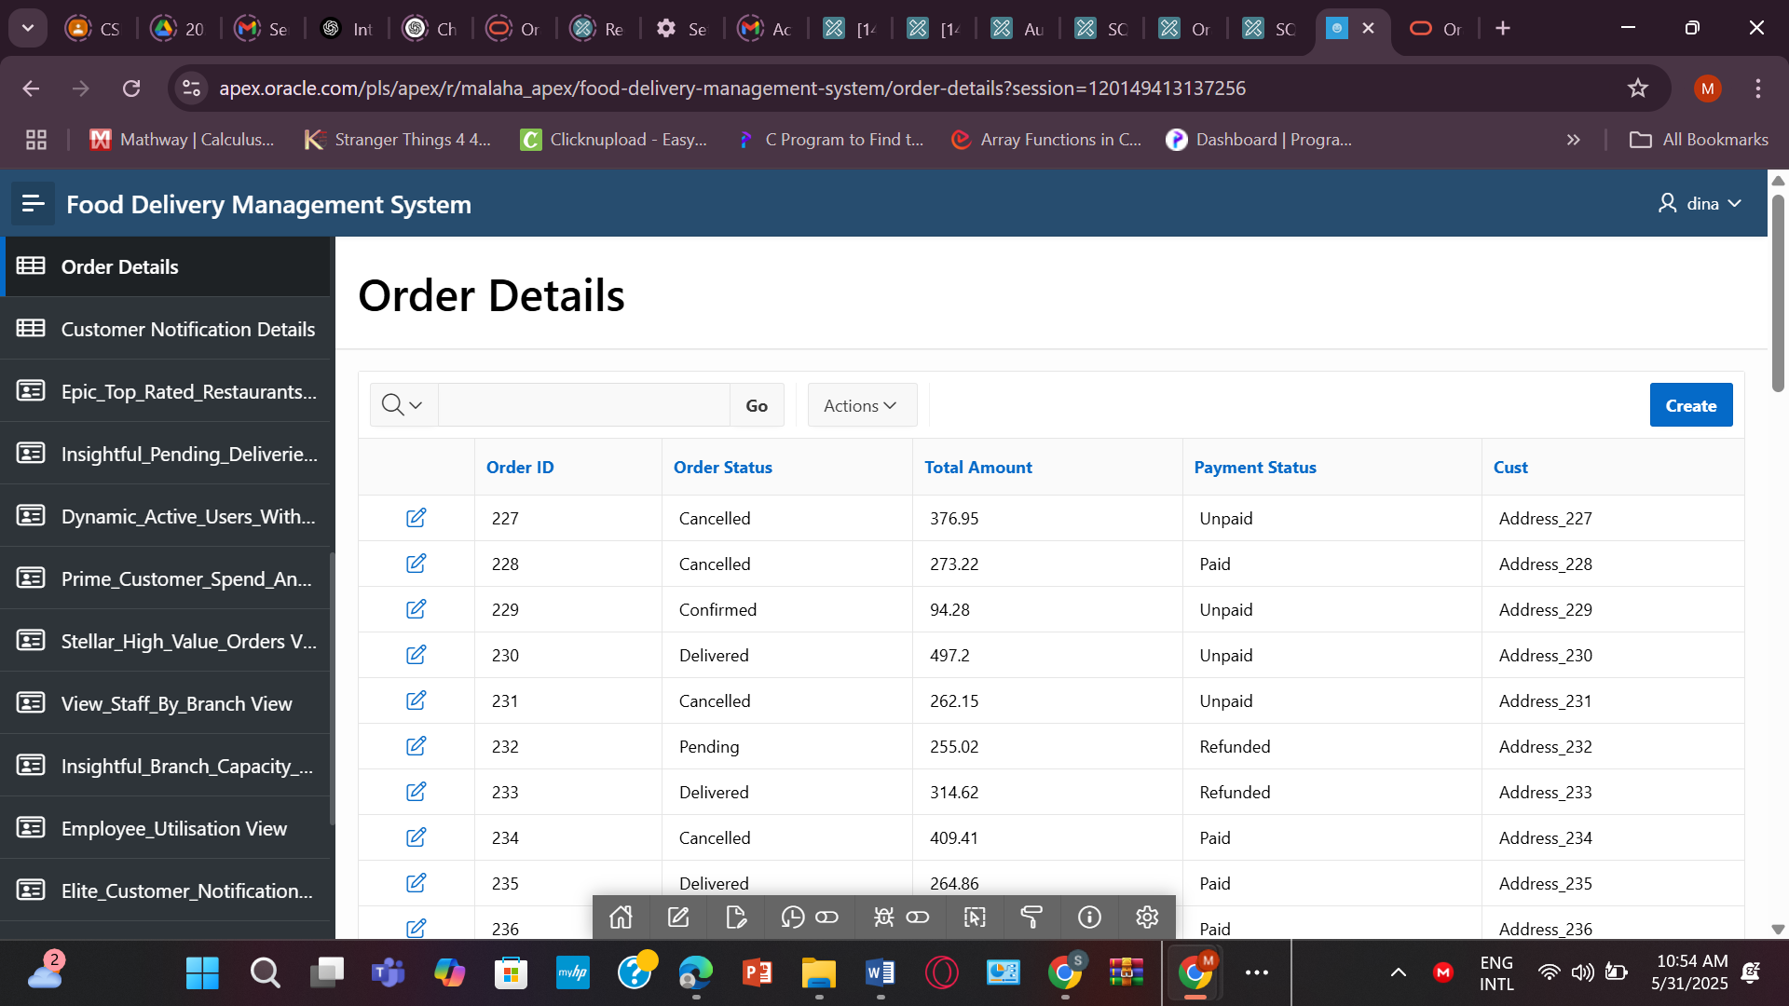**

**VIEW:**

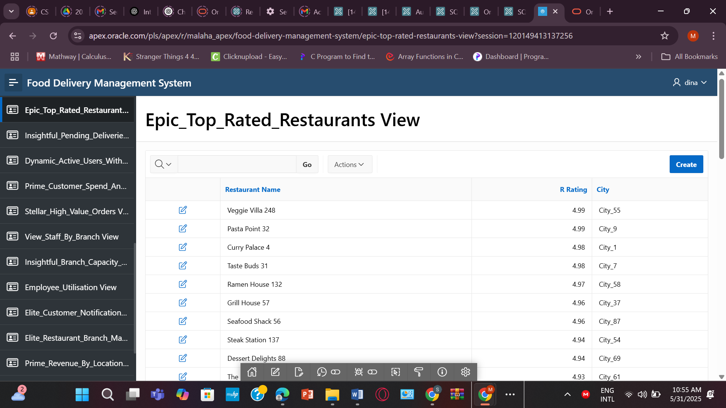

1. **CREATE OR REPLACE VIEW Epic_Top_Rated_Restaurants AS**

**SELECT Restaurant_Name, R_Rating, City, Area**

**FROM RESTAURANT R**

**JOIN LOCATION L ON R.LocationID = L.Location_ID**

**WHERE R.R_Rating >= 4.5**

**ORDER BY R.R_Rating DESC;**

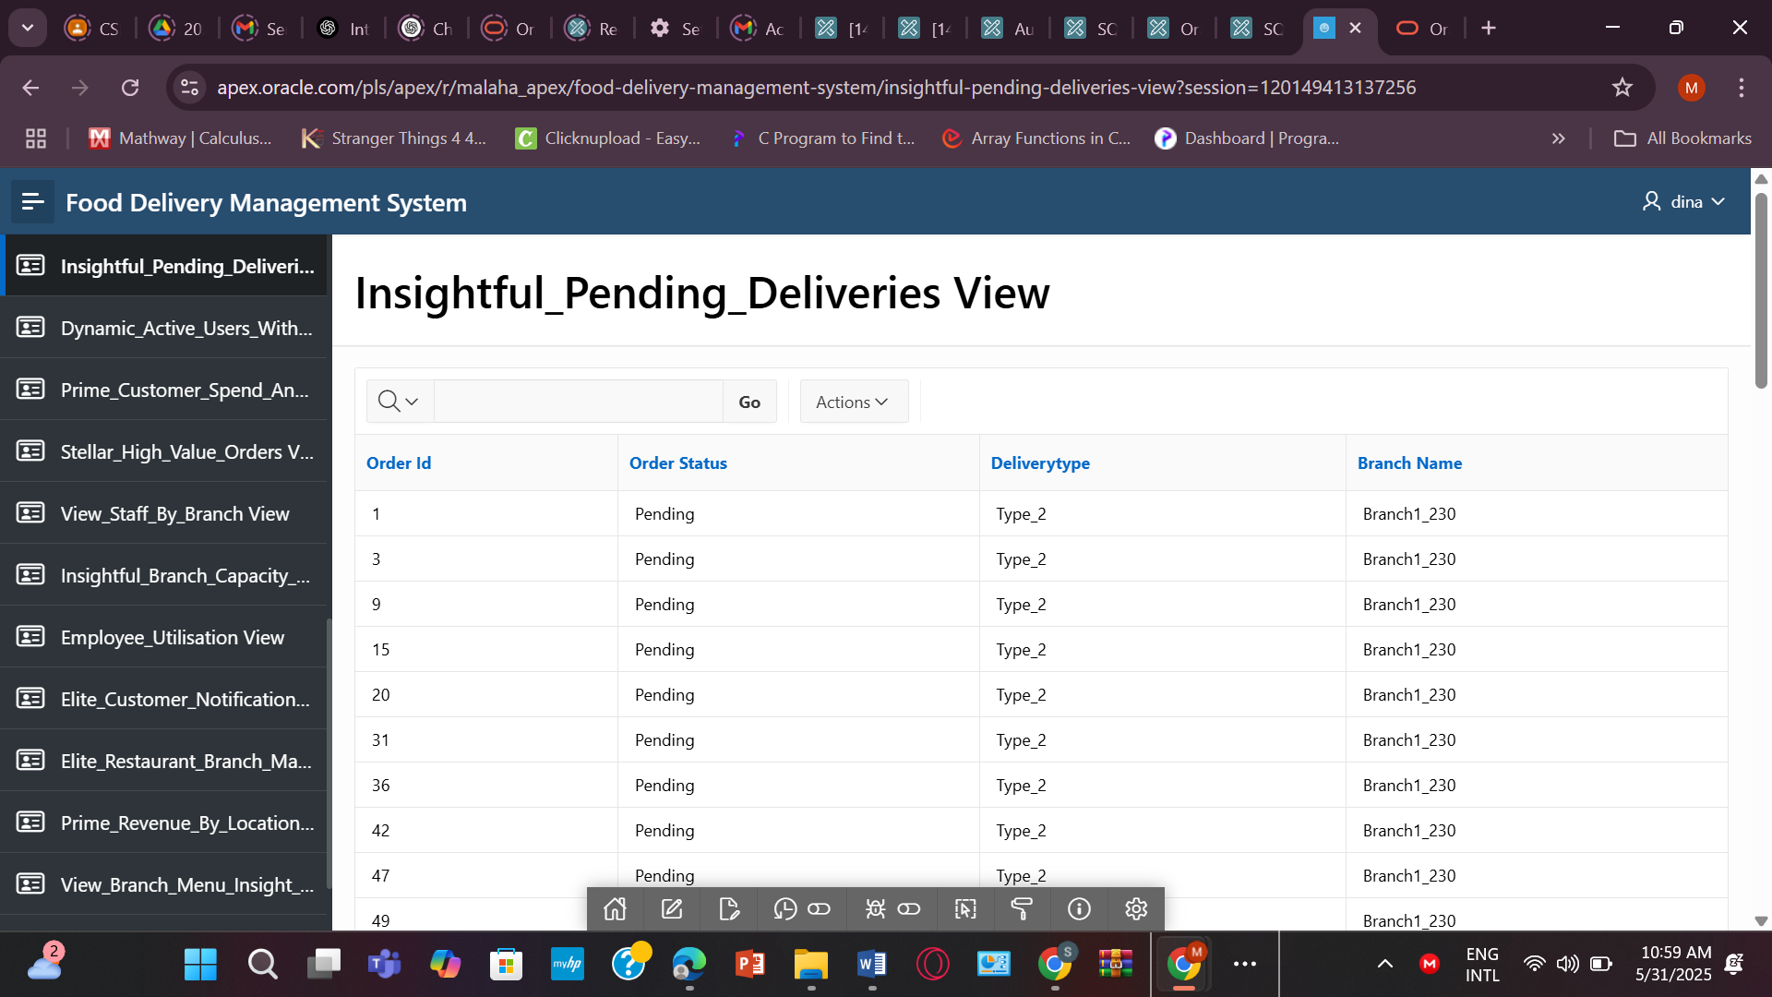

**2.CREATE OR REPLACE VIEW Insightful_Pending_Deliveries AS**

**SELECT**

**O.Order_ID,**

**O.Order_Status,**

**D.DeliveryType,**

**B.Branch_Name**

**FROM ORDERS O**

**JOIN ORDER_PAYMENT OP ON O.Order_ID = OP.Order_ID**

**JOIN BRANCH_1 B ON O.Cust_ID IS NOT NULL**

**JOIN DELIVERY D ON D.Branch_ID = B.Branch_ID**

**WHERE O.Order_Status = 'Pending';**

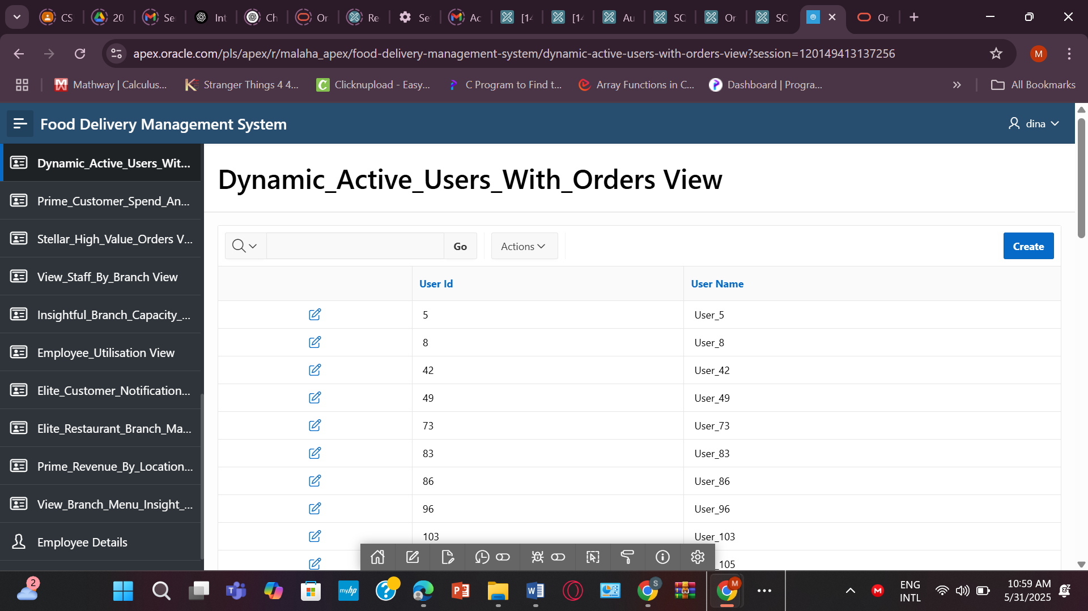

**3.CREATE OR REPLACE VIEW Dynamic_Active_USERS_With_Orders AS**

**SELECT DISTINCT U.User_ID, U.User_Name**

**FROM USER_ U**

**JOIN CUSTOMER C ON U.User_ID = C.User_ID**

**JOIN ORDERS O ON C.Cust_ID = O.Cust_ID;**

**CREATE OR REPLACE VIEW Stellar_High_Value_Orders AS**

**SELECT Order_ID, Total_Amount, Payment_Status**

**FROM ORDERS**

**WHERE Total_Amount >= 200**

**ORDER BY Total_Amount DESC;**

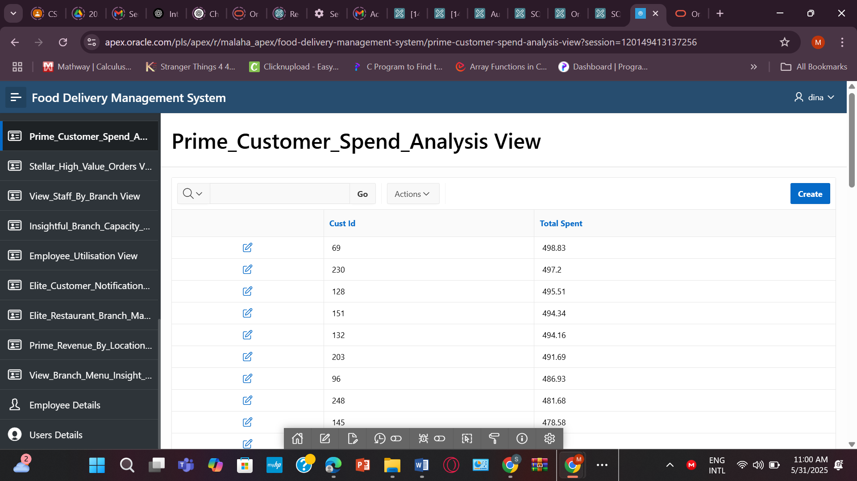

**4.CREATE OR REPLACE VIEW Prime_Revenue_By_Location AS**

**SELECT L.City, L.Area, SUM(O.Total_Amount) AS Total_Revenue**

**FROM ORDERS O**

**JOIN CUSTOMER C ON O.Cust_ID = C.Cust_ID**

**JOIN RESTAURANT R ON C.NotificationID = R.Restaurant_ID**

**JOIN LOCATION L ON R.LocationID = L.Location_ID**

**GROUP BY L.City, L.Area**

**ORDER BY Total_Revenue DESC;**

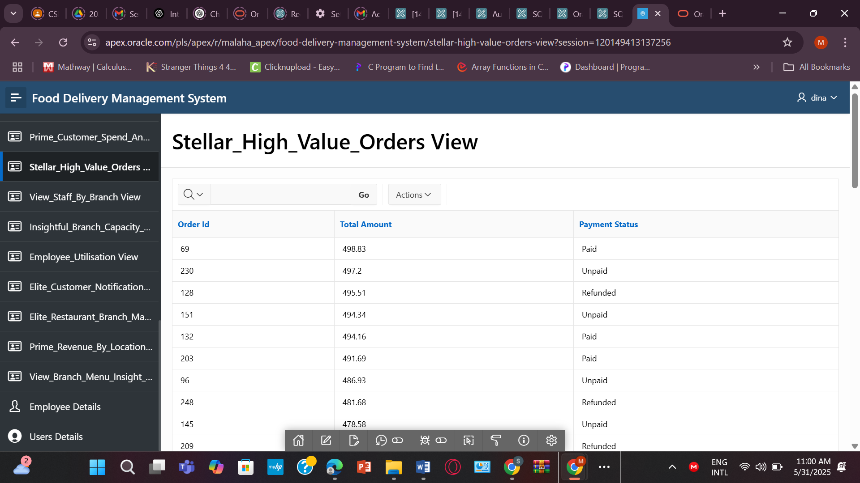

**5. CREATE OR REPLACE VIEW Stellar_Employee_Utilisation AS**

**SELECT Emp_ID, Position, Working_hour, Available_hour,**

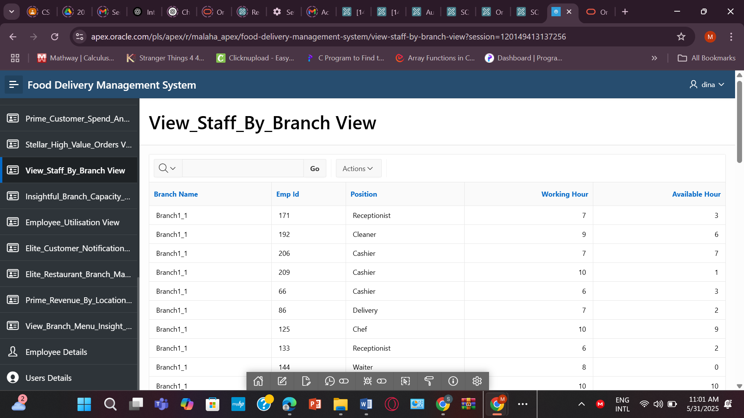

**6.CREATE OR REPLACE VIEW View_Staff_By_Branch AS**

**SELECT**

**B.Branch_Name,**

**E.Emp_ID,**

**E.Position,**

**E.Working_hour,**

**E.Available_hour**

**FROM EMPLOYEE E**

**JOIN BRANCH_1 B ON E.Branch_ID = B.Branch_ID;**

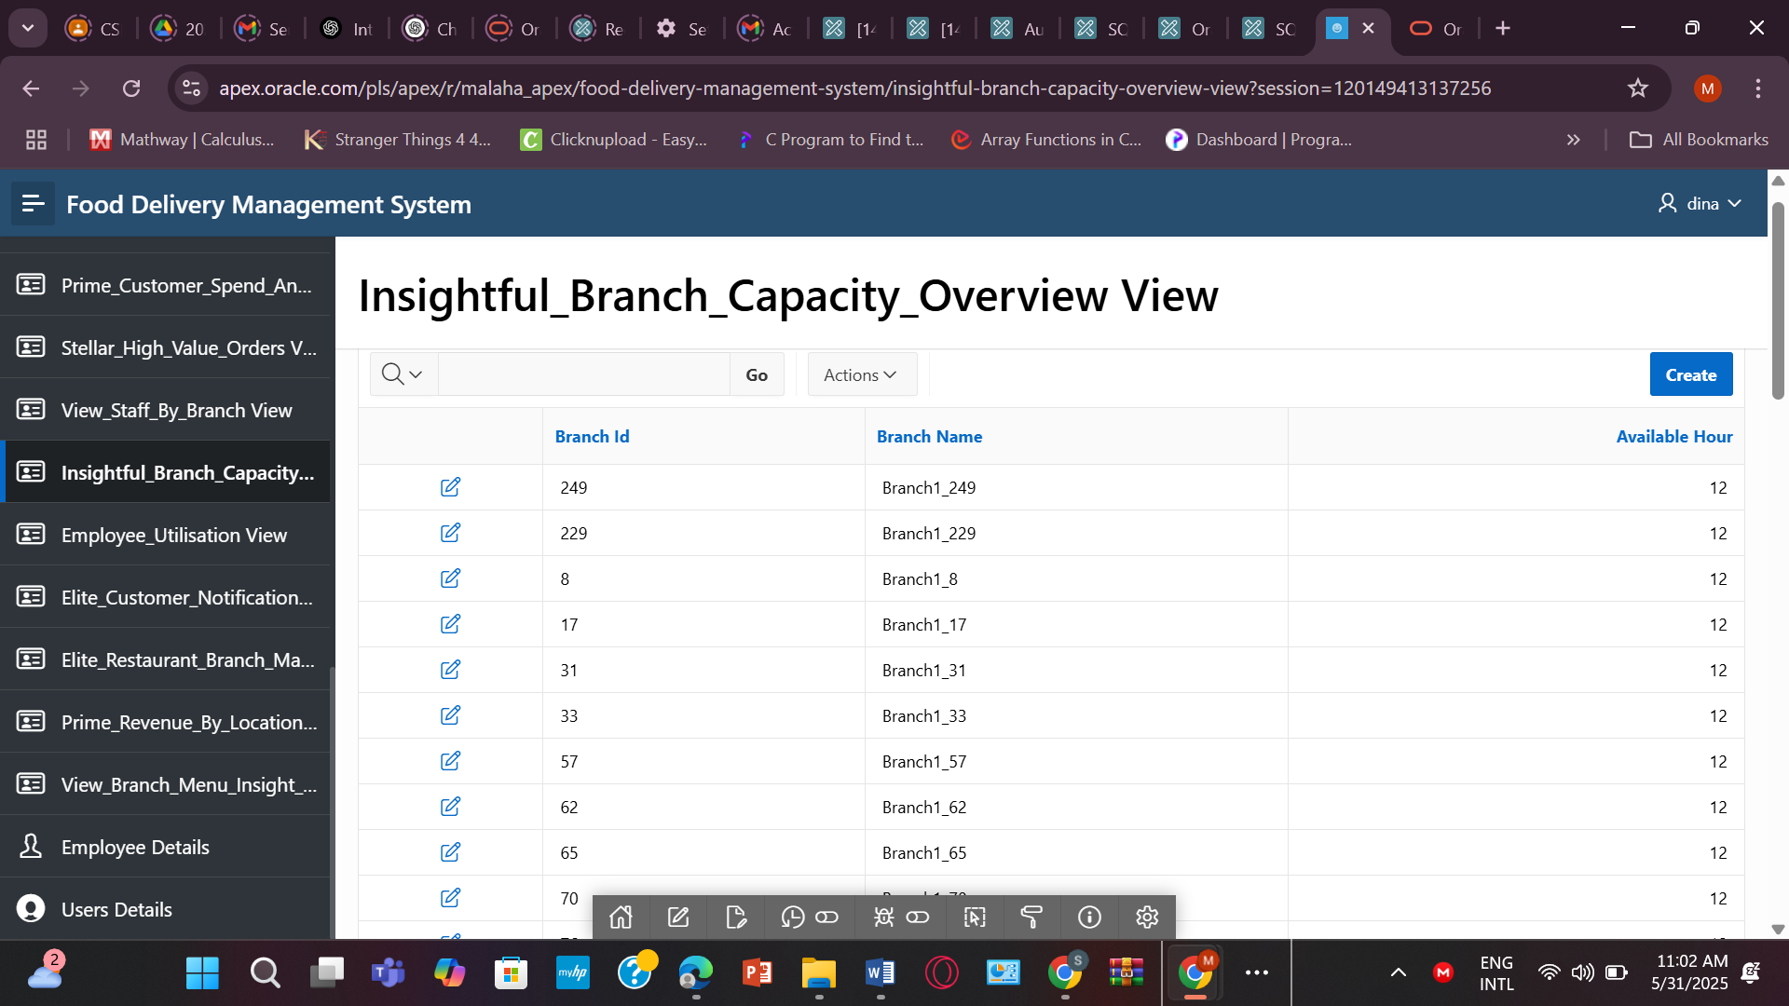

**7.** **CREATE OR REPLACE VIEW Insightful_Branch_Capacity_Overview AS**

**SELECT Branch_ID, Branch_Name, Available_hour**

**FROM BRANCH_1**

**ORDER BY Available_hour DESC;**

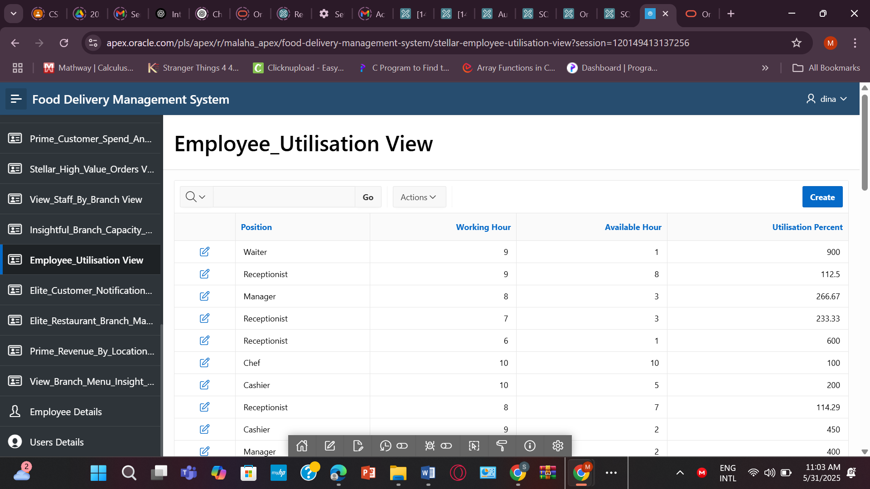

**8.** **CREATE OR REPLACE VIEW Stellar_Employee_Utilisation AS**

**SELECT Emp_ID, Position, Working_hour, Available_hour,**

**ROUND((Working_hour/Available_hour)*100, 2) AS Utilisation_Percent**

**FROM EMPLOYEE**

**WHERE Available_hour > 0;**

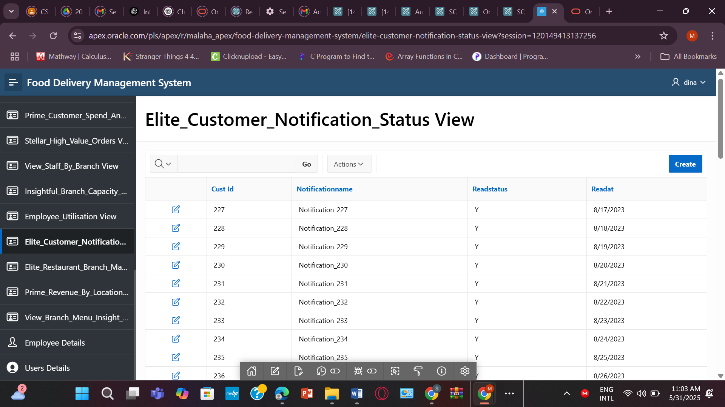

**9.** **CREATE OR REPLACE VIEW Elite_Customer_Notification_Status AS**

**SELECT CN.Cust_ID, N.NotificationName, CN.ReadStatus, CN.ReadAt**

**FROM CUSTOMER_NOTIFICATION CN**

**JOIN NOTIFICATION N ON CN.NotificationID = N.NotificationID;**

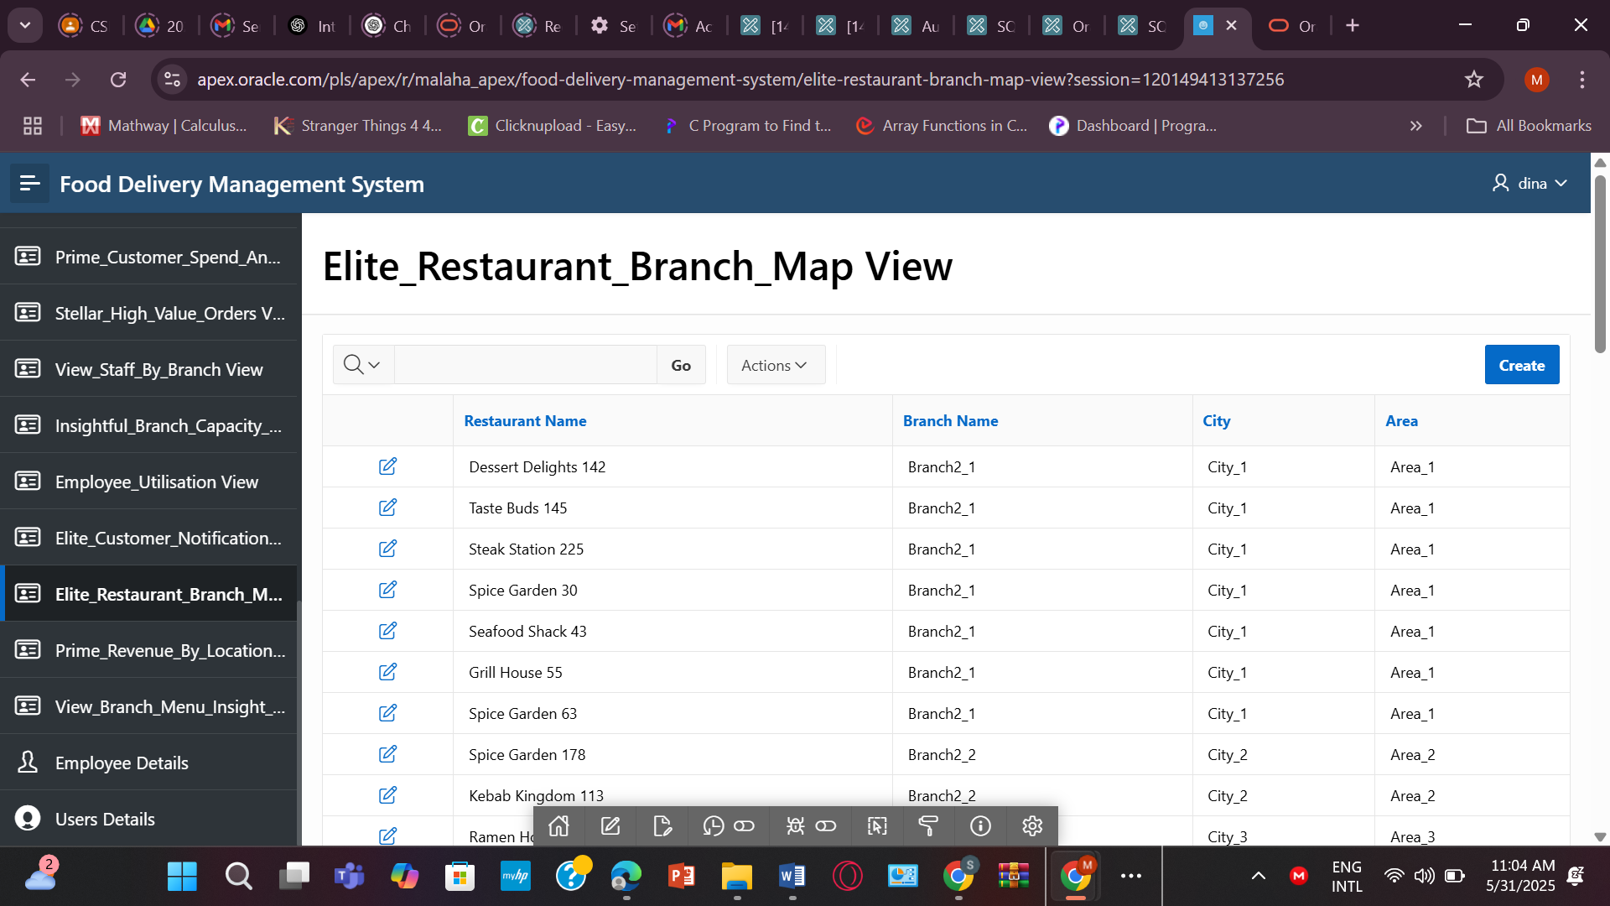

**10.** **CREATE OR REPLACE VIEW Elite_Restaurant_Branch_Map AS**

**SELECT R.Restaurant_Name, B.Branch_Name, L.City, L.Area**

**FROM RESTAURANT R**

**JOIN BRANCH_2 B ON R.Branch_ID = B.Branch_ID**

**JOIN LOCATION L ON B.Location_ID = L.Location_ID;**

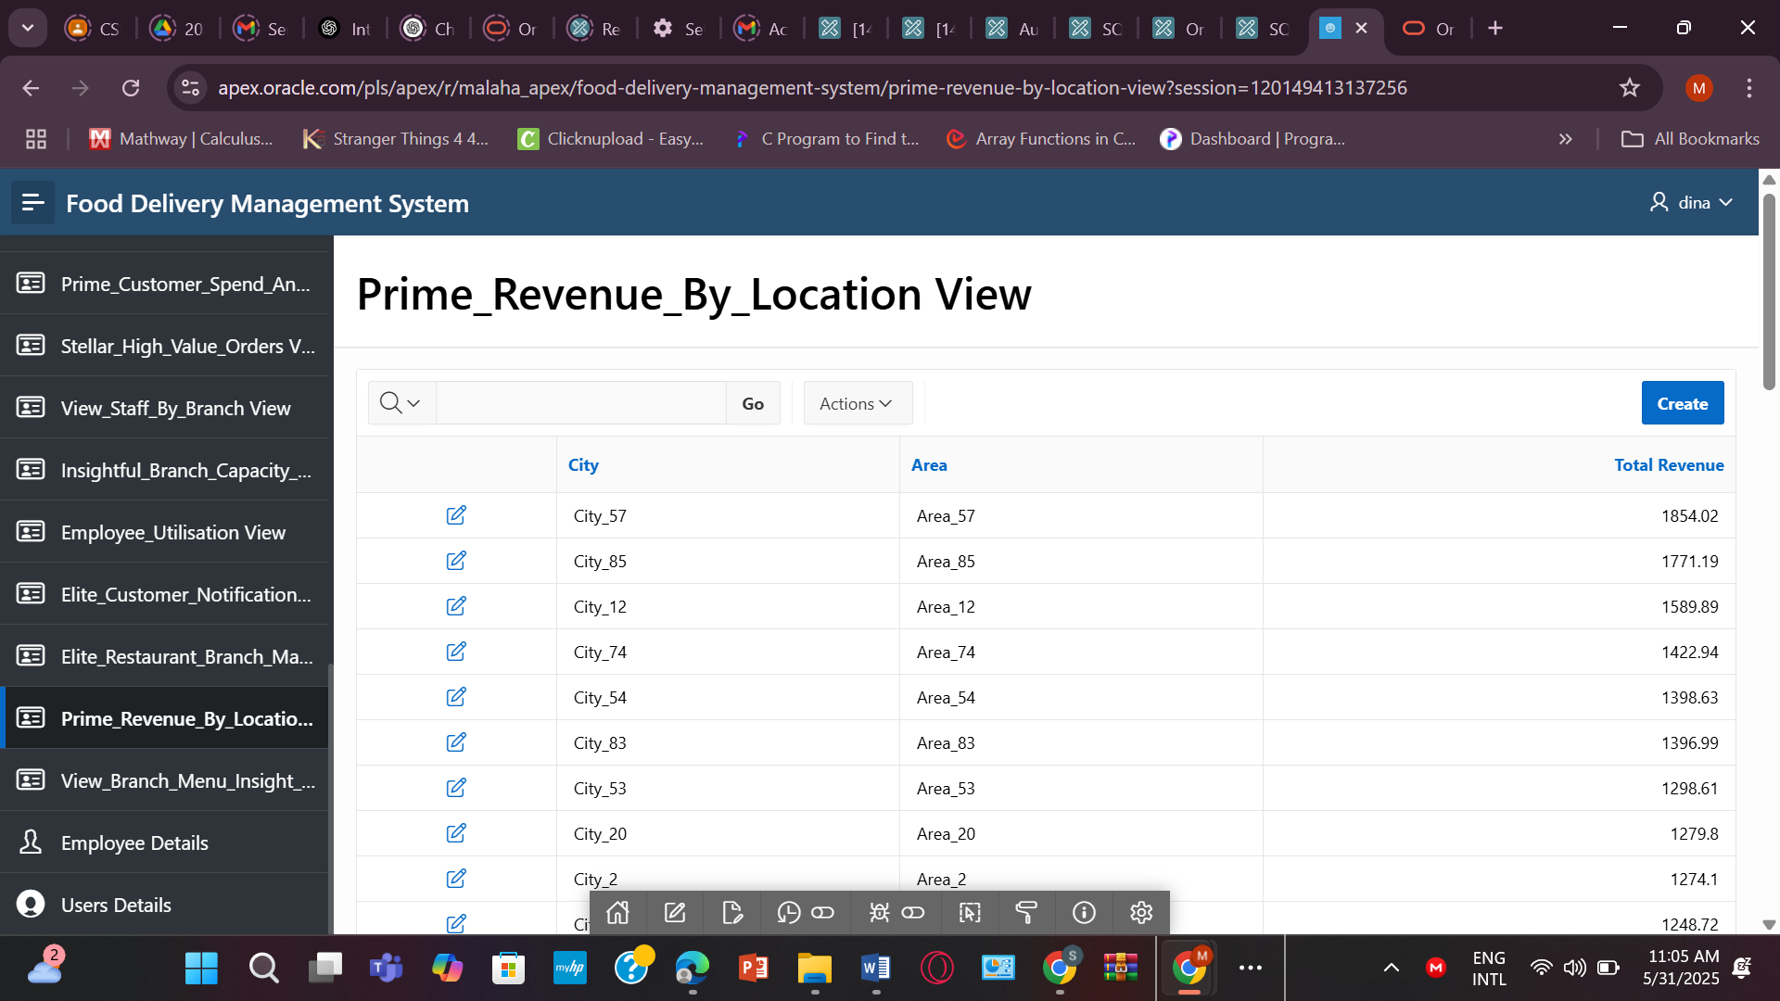

**11.** **CREATE OR REPLACE VIEW Prime_Revenue_By_Location AS**

**SELECT L.City, L.Area, SUM(O.Total_Amount) AS Total_Revenue**

**FROM ORDERS O**

**JOIN CUSTOMER C ON O.Cust_ID = C.Cust_ID**

**JOIN RESTAURANT R ON C.NotificationID = R.Restaurant_ID**

**JOIN LOCATION L ON R.LocationID = L.Location_ID**

**GROUP BY L.City, L.Area**

**ORDER BY Total_Revenue DESC;**

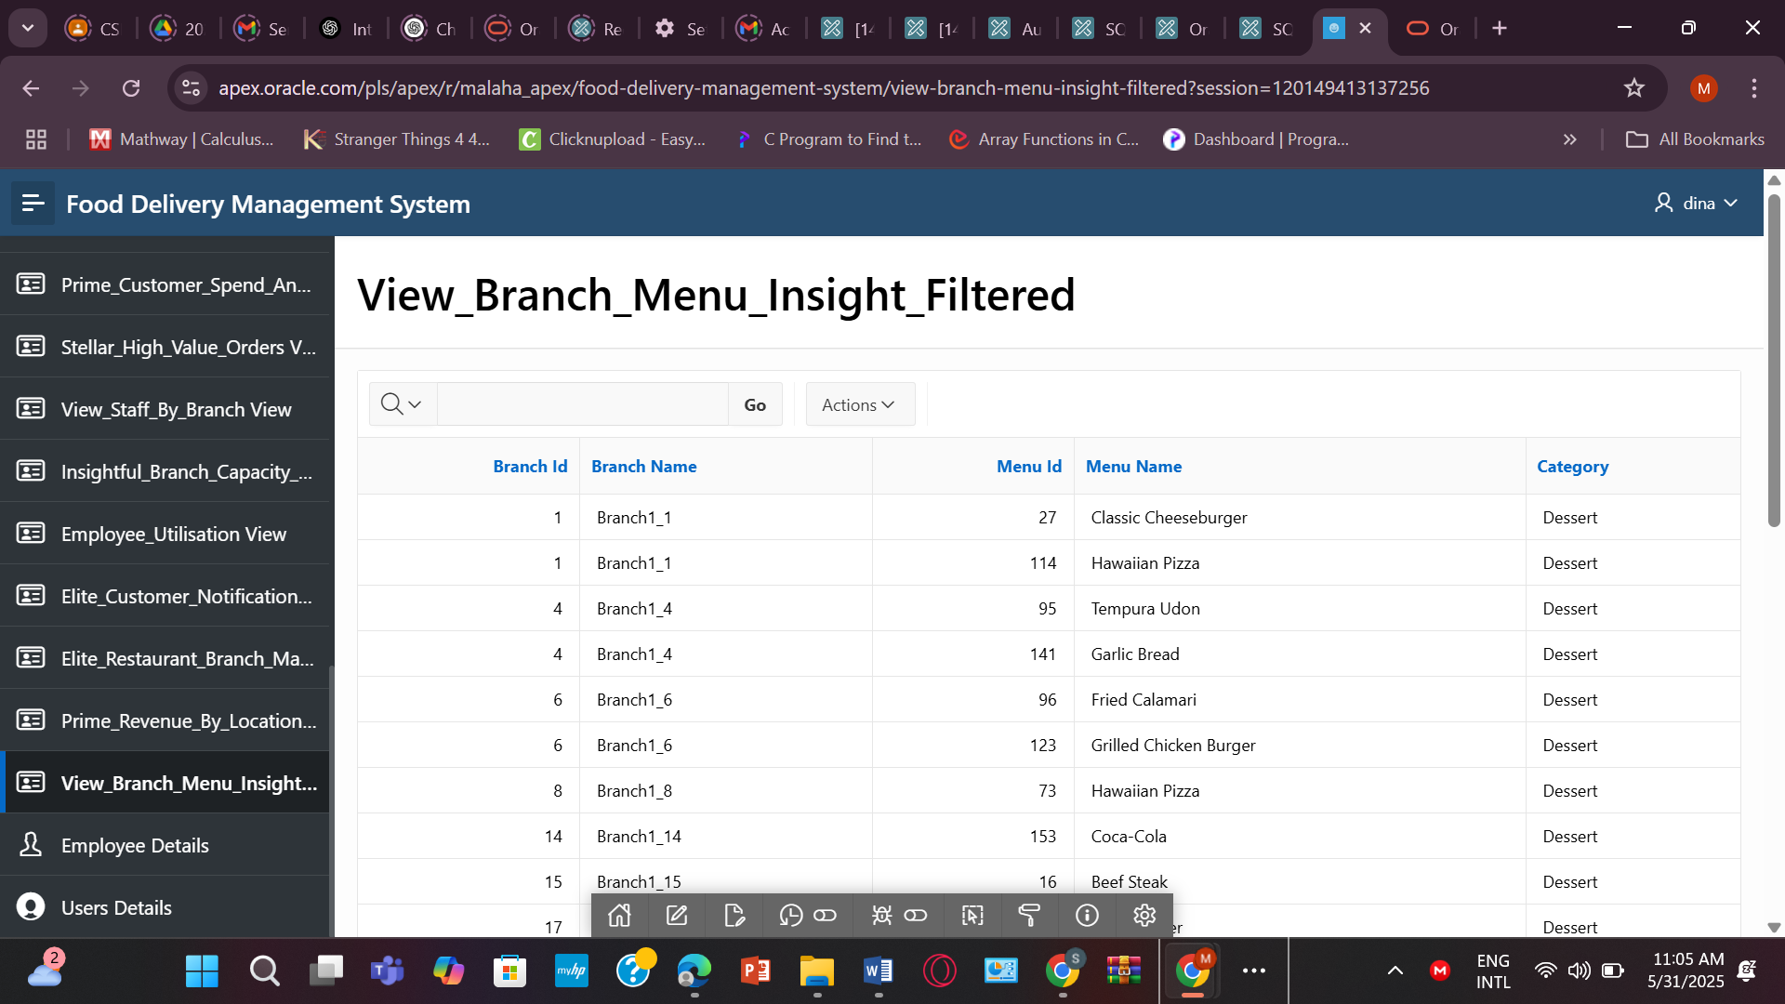

**12.** **CREATE OR REPLACE VIEW View_Branch_Menu_Insight_Filtered AS**

**SELECT**

**B.Branch_ID,**

**B.Branch_Name,**

**M.Menu_ID,**

**M.Menu_Name,**

**M.Category**

**FROM BRANCH_1 B**

**JOIN MENU M ON B.Branch_ID = M.Restaurant_ID**

**WHERE M.Category IN ('Snacks', 'Dessert');**

**TABLE FORM:**

* **EMPLOYEE**

**CREATE TABLE EMPLOYEE (**

**Emp_ID NUMBER PRIMARY KEY,**

**Joining_Date DATE NOT NULL,**

**Salary NUMBER(10,2),**

**Position VARCHAR2(50),**

**Working_hour NUMBER,**

**Available_hour NUMBER,**

**Branch_ID NUMBER NOT NULL,**

**User_ID NUMBER,**

**CONSTRAINT fk_emp_user FOREIGN KEY (User_ID) REFERENCES USER_(User_ID),**

**CONSTRAINT fk_emp_branch FOREIGN KEY (Branch_ID) REFERENCES BRANCH_1(Branch_ID)**

**);  
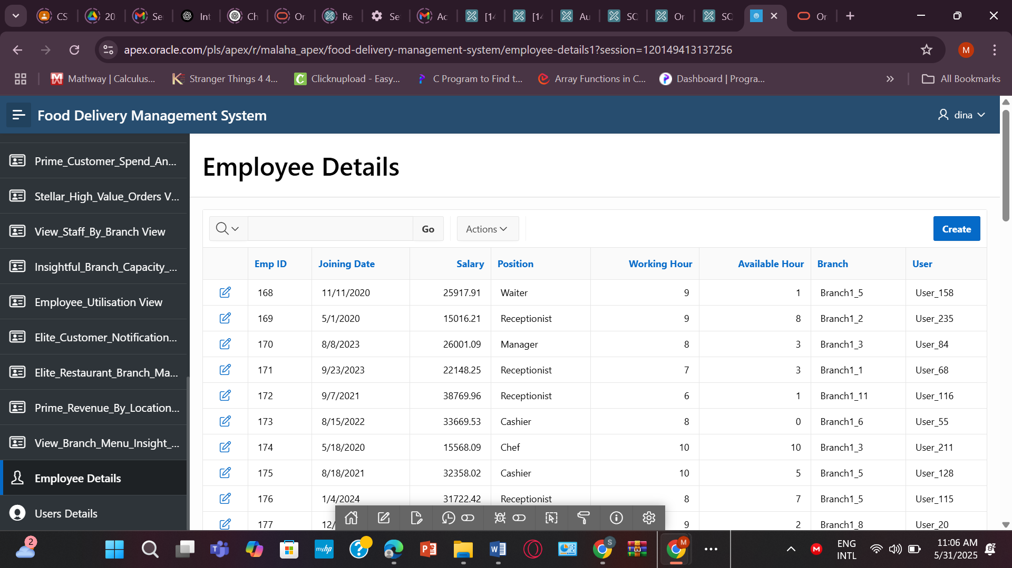**

**For Authorization & Authentication  
CREATE TABLE USERS**

**( USER_ID INT NOT NULL,**

**USER_NAME VARCHAR2(100) NOT NULL,**

**USER_PASS VARCHAR2(100) NOT NULL,**

**USER_ROLL VARCHAR2(100) NOT NULL,**

**USER_ACTIVATED NUMBER DEFAULT 0,**

**PRIMARY KEY (USER_ID)**

**) ;**

**INSERT INTO USERS (USER_ID, USER_NAME, USER_PASS, USER_ROLL, USER_ACTIVATED) VALUES (1, 'Pro', 'pro123', 'admin', 1);**

**INSERT INTO USERS (USER_ID, USER_NAME, USER_PASS, USER_ROLL, USER_ACTIVATED) VALUES (2, 'Dina', 'dina1234', 'user', 1);  
